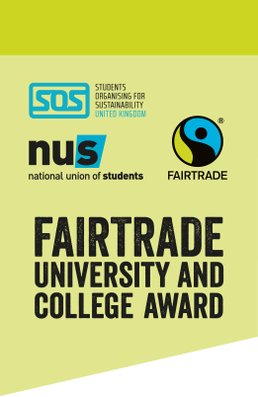
Become a Student Auditor for the Fairtrade University & College Award!

Voluntary role, approx 6 hours total, including:
- A training session delivered by SOS-UK and the Fairtrade Foundation, via Zoom
- A remote audit at your university or college
The Fairtrade University & College Award
Our research shows that the ethical standards of products matter to 89% of students, and 90% of students say that they want to buy more products that don’t harm the people who produce them. Students associate high ethical standards with Fairtrade and want to see more Fairtrade products on campus.

That’s why the Fairtrade Foundation and the National Union of Students (NUS) launched the new award for universities and colleges to achieve Fairtrade status. Universities and colleges taking part in the award have been working to improve their promotion of, and engagement with, Fairtrade products and the Fairtrade mark. In order to achieve the award, a student-led audit will be conducted at each university and college to verify their level of achievement.

The role of a student auditor
Student auditors will work in groups of two or three to audit all aspects of their own university or college’s work on the Fairtrade award. You will firstly be fully trained on the award criteria and how to conduct an audit by SOS-UK and the Fairtrade Foundation in a training session conducted over Zoom. You will then meet with staff at your university or college to conduct the audit, which should take about two hours.

Desirable Qualities
No technical knowledge is needed as full training will be provided However, there are a few desirable qualities that a student auditor would already have:
- A passion for ethical purchasing
- An interest in social and ethical issues
- Confident speaking to new people, and working within a team
- Competent with use of Microsoft Excel
- Ability to act in a professional manner
Skills you will gain:
- Leadership
- Communication
- Presentation skills and public speaking
- Time management
- Problem solving

You will also have the opportunity to be part of a new award, meet like-minded students and learn more about Fairtrade and ethical consumption.

How do I get involved?
Register your interest by filling out the volunteer application form online by Sunday 18th April: https://survey.sos-uk.org/index.php/811452?lang=en

Spaces may be limited at each university. We will be in touch with successful applicants with details of the training session and the next steps the week after the deadline.

